Proposed Golf Simulator and Indoor Practice Facility

Executive Summary

The aim of this proposal

Provide CGC with a long term, new and valuable income stream, which will:

- Give rapid payback on the initial club investment (projected to be 2.5 years), by committing to a low-risk investment that is within the current CGC budget.
- Enhance member experience and give an opportunity for members to engage in golf at the club when weather conditions do not support normal outdoor golf.
- Utilise existing assets of the club to generate income.
- Create a state of the art facility that, promotes golf skill development and builds on the success of the current outdoor practice facility.
- Match other leading clubs in the north, providing added value golf services to members, which will help to differentiate our club’s facilities from other local competitors.

What do we want to achieve?

Change the use of the old golf shop into a state-of-the-art golf studio using world leading Trackman golf software. Give members a greater service by offering a golf alternative all year round, especially when the course is closed or on dark nights in the winter. Additional member benefits.

Current challenges

Weather conditions are a major factor in our members ability to play golf, particularly in winter. Daylight hours are also reduced meaning the use of the course and clubhouse is restricted. Recent improvements have given CGC a fantastic practice facility, however in inclement conditions or when daylight is limited these facilities may not be attractive to members. Work and other commitments can affect the free time people have, 18 holes of golf can take 4hrs plus, which limit members ability to play golf when conditions are not favourable. This proposal seeks to offer an alternative option for our members to be able to play or practice throughout the whole year, not just when conditions allow.

Aim of the proposal

- Increase member engagement and usage of club facilities.
- Generate additional revenue streams.
- Attract new members and retain existing ones.
- Enhance member satisfaction and training capabilities.
- Utilise unused space within the clubhouse and preserve future use of space above the old professional shop, maintaining flexibility for Club growth.

Market Analysis

The target market for the proposal is:
- Current Members: Golfers of all skill levels looking to play and improve their game all year round.
- Corporate Clients: Businesses seeking unique team-building activities and event venues.
- Junior Golfers: Youth interested in learning and practicing golf using technology.

Research has shown the following market trends:
- A growing interest in new golf technology for training and entertainment.
- Increased demand for indoor sports facilities due to weather variability.
- Rising popularity of data-driven sports improvement methods.

How the facility would work

Trackman 4 Golf Simulator (no investment from CGC, cost £24k):
- Dual Radar Technology: Provides precise tracking of club and ball data.
- Virtual Courses: Features replicas of famous golf courses worldwide.
- Training Modules: Offers tailored practice programs for skill improvement.
- Interactive Gameplay: Includes games and challenges for entertainment and competition.
- Ability to provide indoor lessons for members with PGA Professional.
- Online booking system to book simulator/lessons.
- Key card or key code entry system for out of hours simulator hire.
- See the technology here: https://www.youtube.com/watch?v=xxjkOVK2sTw

Benefits

Revenue Generation:
- Hourly rental rates for simulator use.
- Corporate event packages and private party rentals.
- Encourages members to spend more time at the club as this is an added value offering.

Enhanced Training and Skill Development:
- Precision tracking for accurate performance analysis.
- Customisable practice sessions for targeted improvement.
- Video playback and swing analysis to identify and correct errors.

Increased Member Engagement:
- Year-round golf facility unaffected by weather conditions.
- Hosting of virtual tournaments and competitions.
- Social events and gatherings centered around the simulator for example; a golf evening whilst watching The Masters.
- Member lessons throughout winter and dark evenings.

Staff Training and Support:
- Train club shop staff on operating and maintaining the simulator.
- Develop tutorial sessions and guides for members.
- Online booking system and club shop support for members using the facility

Financial Summary

- CGC initial investment in fitting out the old pro-shop area: £20k
- Club Professional to fund and supply Trackman 4. Investment in Trackman 4 technology CGC £0 (Club Professional £24,000).
- Expected payback on initial investment after 2.5 years, based on projected figures.
- Booking plan year 1 – averaging 10 hours per week over the full year @ £20/hour.
- Corporate total annual income - £2400.
- Total income year 1 – £12,800
- Hourly rate income split: CGC 70%, Club Professional 30%.
- Additional annual operating costs to the club (Heating, lighting and additional maintenance contracts) £1150.
- Approximately £7,810 expected net income generated for CGC annually, in addition to all the wider benefits noted for members above.

How will it look?

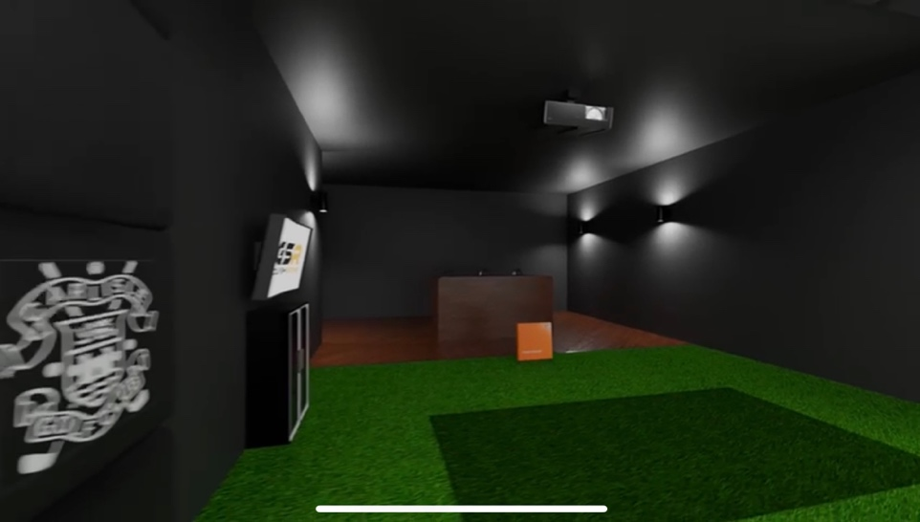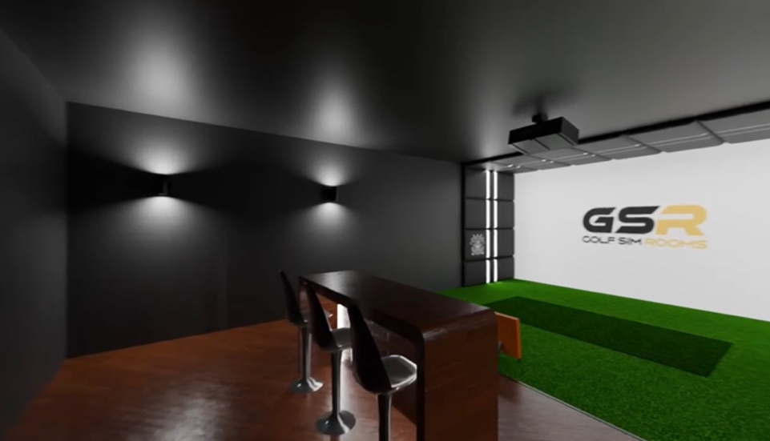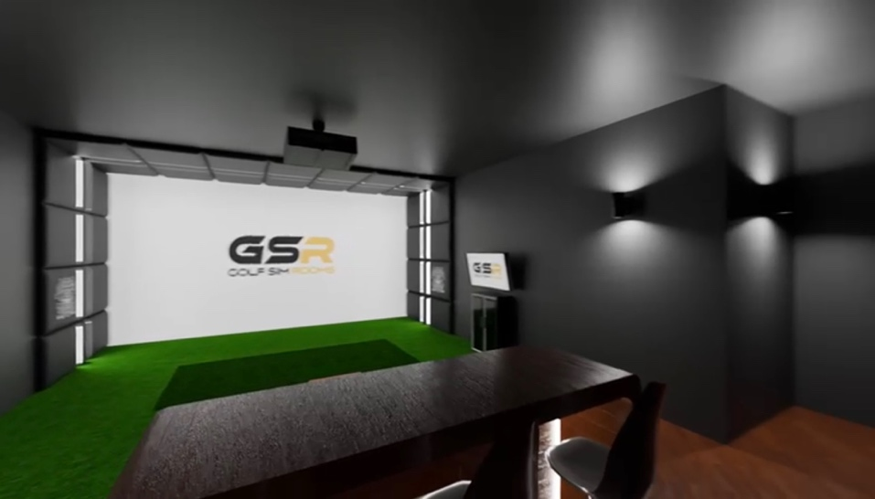

Conclusion

Introducing the Trackman 4 golf simulator at Carlisle Golf Club represents a low risk strategic investment to enhance member experience, increase engagement and generate additional revenue. By carefully planning and executing this proposal, the club can position itself as a leader in providing advanced golfing facilities, attracting new members and retaining existing ones.

FAQs

Following the consultation period, we have carefully reviewed all the questions raised by members. Below, we have provided answers to each of these queries to ensure clarity and transparency regarding the proposed golf simulator project.

1. “Can you provide an approximate cost for the club and for the pro’s contribution?”
Answer: The cost to the club for fitting out the room is £20k with annual running costs of £1,150. The PGA Professionals contribution is £24,000 for the Trackman unit, which he is funding directly. With the Club professional providing the TrackMan unit, it allows the project to be established at lower cost and risk initially for the club.

2. “How much will members be charged for using this?”
Answer: The planned cost for members is £20 per hour. For example, on a wet winter day, a four-ball could enjoy a round on the Old Course at St Andrews together for just £5 per person.

3. “How much money will the golf club make annually from this project?”
Answer: The ROI for this project is estimated to generate approximately £7,810 in net income for CGC in year one, with most of the income coming from member usage and corporate events. The plan assumes the simulator will be used primarily during the winter months when demand is higher, ensuring member engagement. 3 scenarios have been used, the lowest return model still provides an acceptable level of return on investment.

4. “If Nicky is funding this simulator himself & not the club, then presumably he will control the timetable & prioritise his own bookings over members use? How do we control/monitor this?”
Answer: The simulator will be managed through an online booking system, following the same format as our current tee-time bookings. Members will be able to book either independent use of the simulator or lessons with the PGA Professional in the facility. The booking calendar will operate on a two-week rolling basis, with slots allocated on a first-come, first-served basis. This ensures equal opportunity for all members, prevents block-booking, and maintains transparency, as availability will be visible to everyone.

5. “Is the club charging Nicky for the use of this room - fit out, lighting & heating, electricity etc or do we allow him 100% profit?”
Answer: The club will not charge the club professional for the use of the room, its fit-out or the lighting and heating costs. The income is split: 70% of the hourly rental fees will go to the club, and 30% will go to the club professional. This ensures that the club retains the majority of income from the simulator's use. The Professional is providing the TrackMan unit which he has funded for use by club members (cost £24K) as part of the plan to establish the simulator room at the club.

6. “Could there be a solo/practice rate? Could it be priced per person rather than by the hour?”
Answer: The current plan is based on hourly pricing, but we are open to exploring a per-person rate for specific bookings. Introducing a solo practice rate during off-peak times is a possibility. However, we believe it's best to evaluate the usage patterns over the first few months before finalizing these options. When the project is established there will be opportunities to refine the use of the simulator to maximise both use by members and return for the Club.

7. “Has the committee looked at when the simulator will be used?”
Answer: The simulator is designed primarily for winter use, when weather conditions and shorter daylight hours limit members' access to the course. While demand may decrease during the lighter months, this period presents an opportunity to utilise the simulator for corporate events and additional member competitions.

8. “Insurance? Risk if injured? Damage or theft of Trackman? Is this down to Nicky or the club?”
Answer: The PGA Professional will be responsible for insuring the Trackman unit against theft, accidental damage, and technical failure. The club’s existing public liability cover will extend to members and guests using the facility, but the equipment itself will remain the owner’s responsibility. Our insurers are fully informed of our plans as we do for any projects undertaken at the club.

9. “Maintenance of the Trackman and annual subscriptions - essential to keep the technology updated.”
Answer: The maintenance of Trackman and its annual software subscriptions will be covered by the club professional. The club will not be responsible for these ongoing costs.

10. “Could there be a simulator membership option?”
Answer: A simulator membership option is a great idea and could be explored to provide members with discounted or unlimited access to the simulator for a flat fee. However, we believe it's best to evaluate the usage patterns over the first few months before finalizing these options.

11. “How many members can use it at a time?”
Answer: Up to four members can use the simulator at a time. Additionally, larger groups can be accommodated for corporate events and club challenges, such as nearest to the pin or longest drive competitions. It is also hoped that we will be able to provide our sponsors with enhanced value and opportunity to develop new relationships with the Club moving forward.

12. “A Trackman would normally be depreciated over 5 years - does this mean we are guaranteeing Nick’s position for 5 years?”
Answer: The club is making use of the PGA Professional’s Trackman, which he owns, so its depreciation is not a concern to the club. The club professional is an employee of the club and has the same employee responsibilities and protection rights as any other employee.

13. “What happens if he [the club professional] leaves in one year's time? Does he take his Trackman with him or will the club buy it off him?”
Answer: If the club professional leaves in one year, the ownership of the Trackman remains with the professional and the decision on whether the club buys it off him would need to be addressed at the time in a formal agreement. Working with the PGA Professional the Club always has the opportunity to further develop this project including investing in simulator technology. However, it should be recognised that the partnership with the PGA Professional allows the Club to invest in the simulator project at a lower entry cost and reduced level of risk. Options for further development of our practice facilities in general exist as it is clear that our members have a desire to practice, develop their skills and enjoy the challenge of becoming better golfers. This is evidenced by the huge popularity of our practice area during the Summer months.

14. “What is the expected usage ratio between pro and members?”
All our calculations assume member usage of the facility. We’ve forecasted an average of 10 hours of private bookings per week throughout the year, with most bookings expected during the winter months. We have also stress tested this assumption by having two additional scenarios one less optimistic (4 hours per week) and one more optimistic (14 hours per week). All scenarios provide an acceptable return. Calculations have been based on the experience of other clubs, of which there are now many across the country, who have invested in similar projects over the last 5 years.

15. “How are the through life costs of Trackman funded? (Upgrades/maintenance/insurance etc.)”
Answer: Upgrades, maintenance, and insurance are all the responsibility of the club professional as part of his contribution to the project. The club is not financially liable for these ongoing costs.

16. “Will the old pro shop be rented out?”
Answer: This proposal is for the old professional shop to be converted into the simulator room and will not be rented other than as a golf simulator.

17. “Who pays for the heating and electricity?”
Answer: The heating and electricity costs are included in the annual running costs, which the club absorbs as part of the overall facility management, as the club does at present.

18. “Could key card or code access be used to allow entry once the pro shop is closed?”
Answer: Yes, key card or code access will be used to allow members to access the simulator after hours, when the pro shop is closed.

19. “How many stalls would be installed if it passes the vote?”
Answer: Initially, one simulator is planned for installation. If the project is successful, further facilities could be added in the future based on demand. It will be designed to preserve future use of space above the old professional shop, maintaining flexibility for Club growth.

20. “Will the simulator be available during the evening when the clubhouse is closed? If so, how will access be managed?”
Answer: Members will have access to the simulator via key card or code, ensuring secure usage. Health and safety will be monitored through CCTV, with possible restrictions on certain hours. While a staff member won't be required during the evening, the facility will be closely monitored to maintain safety. The simulator will be available after hours, even when the clubhouse is closed, with access controlled through the key card or code system.

21. “What are the extra insurance costs for someone hitting shots inside the clubhouse?”
Answer: The insurance costs for using the simulator inside the clubhouse will be reviewed as part of the club’s overall insurance policy. It is expected that the simulator usage will be covered under general public liability, but specific additional insurance may be needed to address the risks involved.

22. “Is the simulator project not a key matter and should it go to a forum?”
Answer: The simulator project is indeed a key matter, and as required will be put to a member vote.

23. “Has anyone considered putting trackman facilities in the covered bays, similar to those at driving range facilities?”
We are very proud of our practice facilities, which are among the best in the north of England. While a TrackMan range is something we may consider in the future, our current members-only practice ground provides range balls at a very low cost. At present, it would be difficult to offer a TrackMan range service to members while maintaining the competitive pricing they currently enjoy. Typically a trackman range is three to four times the price our members currently pay.

